**EXEMPLO DE COR CORNSILK**  
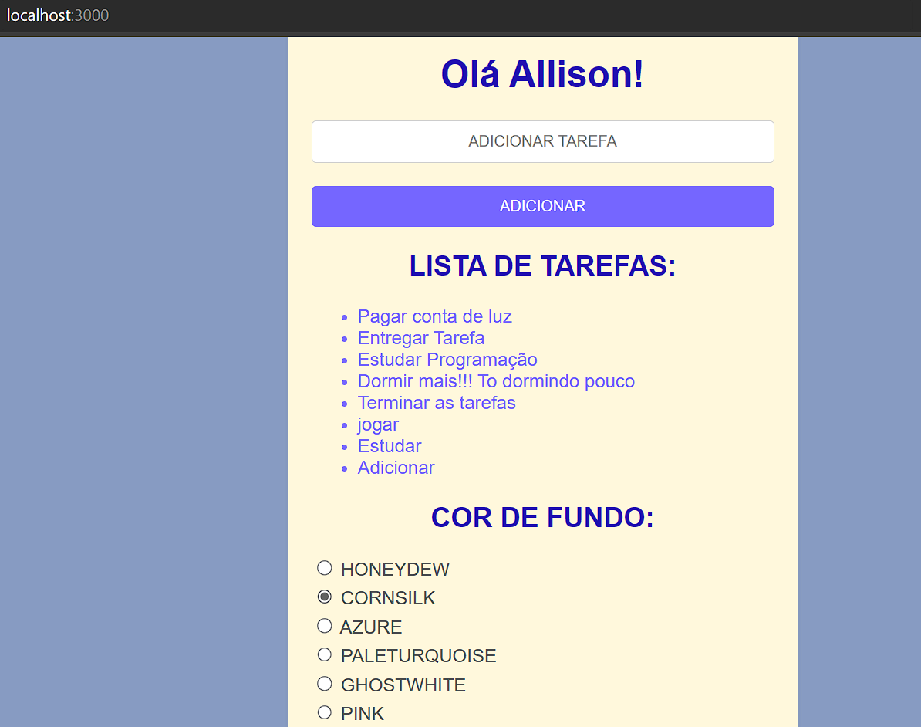  
  
**DADOS SALVOS NO LOCALSTORAGE**  
**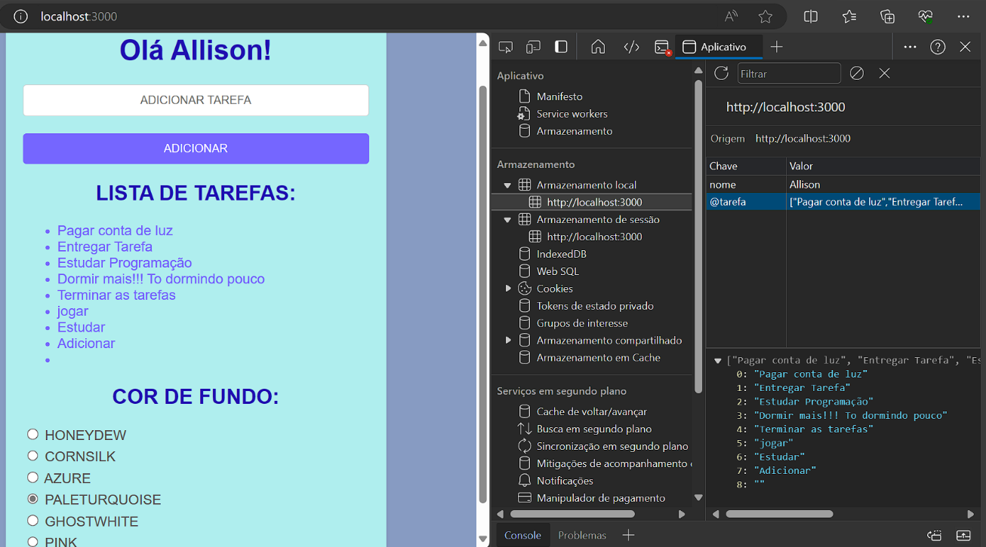  
  
  
EXEMPLO DE COR PALETURQUOISE  
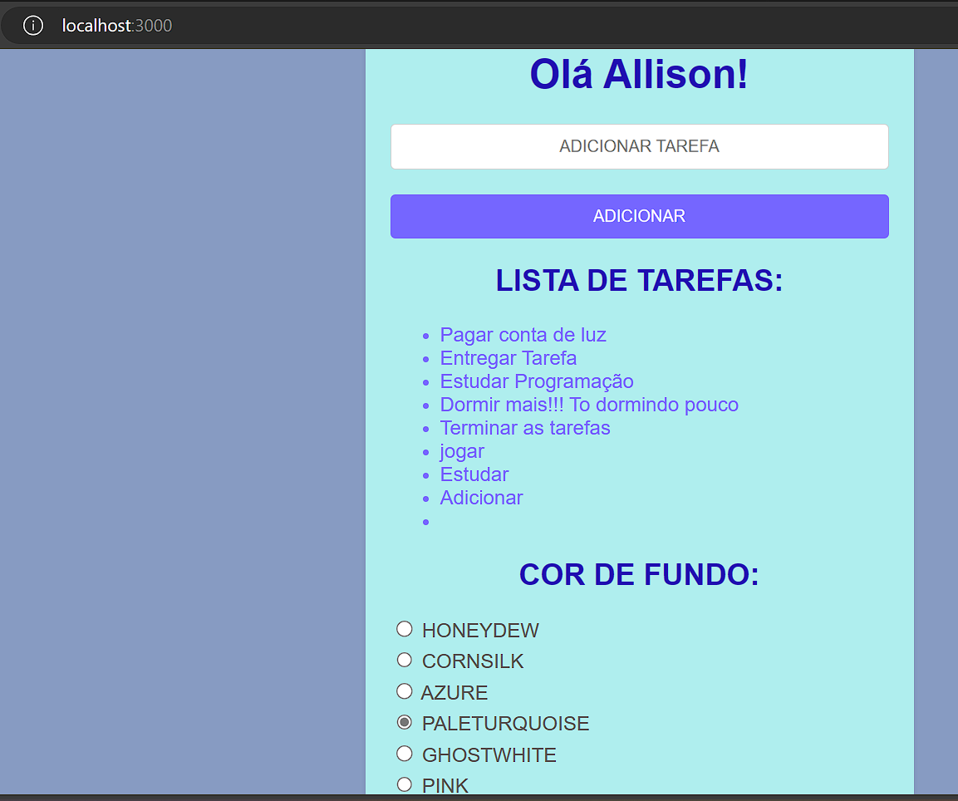  
  
ADICIONANDO NOVA TAREFA EXEMPLO  
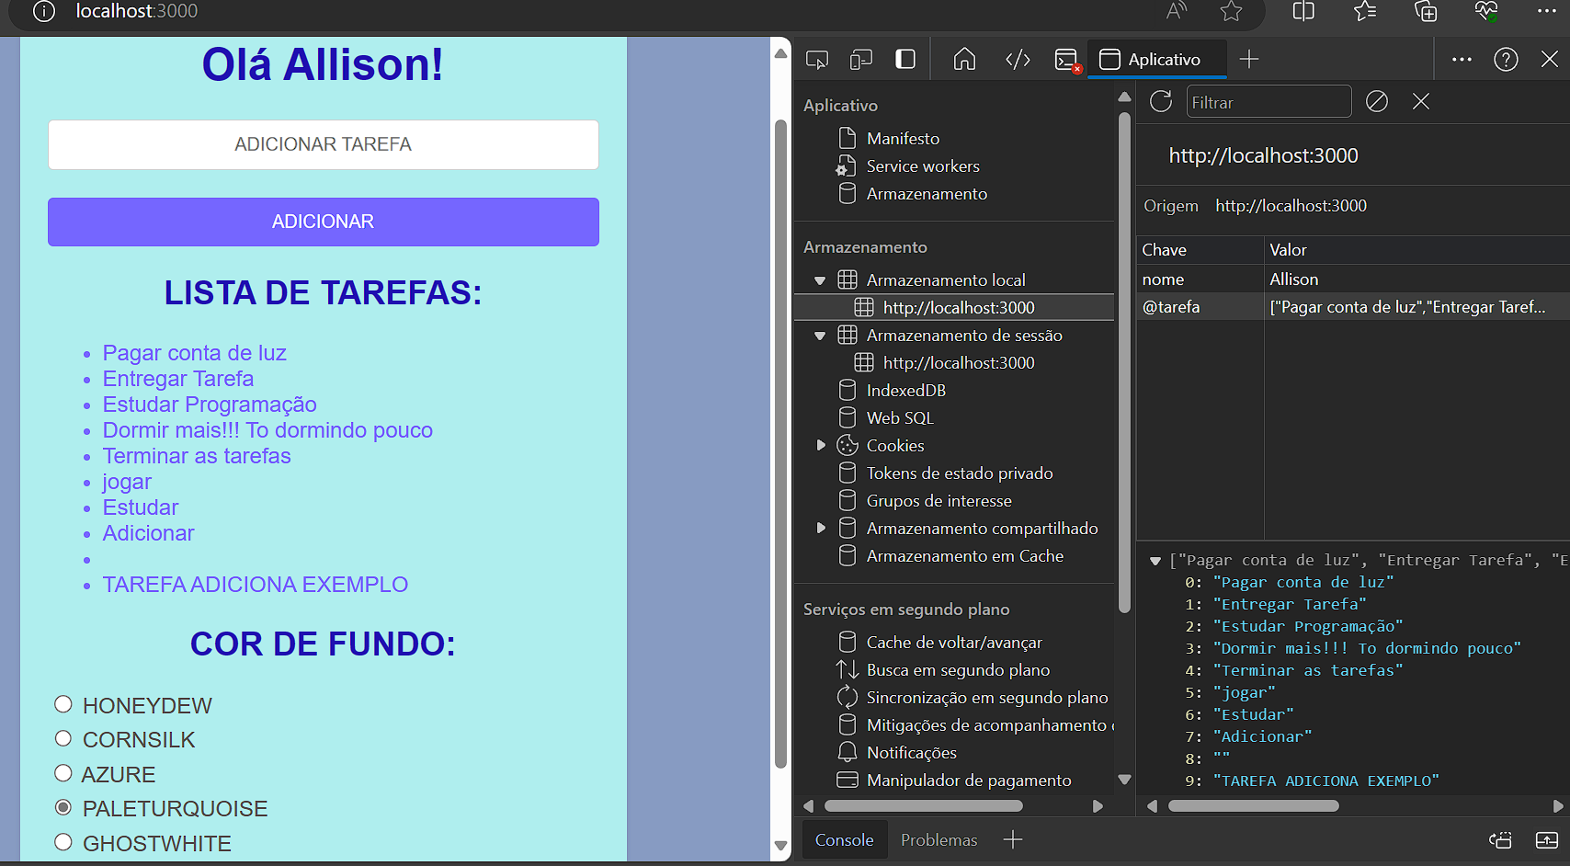**  
**CADASTRO.JS  
  
import React, { useState, useEffect } from 'react';**

**import './Cadastro.css';**

**function Cadastro() {**

**const [input, setInput] = useState('');**

**const [tarefas, setTarefas] = useState([**

**"Pagar conta de luz",**

**"Entregar Tarefa",**

**"Estudar Programação"**

**]);**

**// USEEFFECT DAS TAREFAS:**

**const tarefasStorage = localStorage.getItem('@tarefa');**

**useEffect ( () =>{**

**if(tarefasStorage){**

**setTarefas(JSON.parse(tarefasStorage));**

**}**

**}, []);**

**useEffect ( () =>{**

**localStorage.setItem('@tarefa', JSON.stringify(tarefas));**

**}, [tarefas]);**

**// CRIANDO ALERTA COM O FORMULÁRIO DO NOME:**

**// VARIAVEL**

**const [nome, setNome] = useState('');**

**useEffect(() => {**

**const armazenadoNome = localStorage.getItem('nome');**

**// VERIFICANDO SE JÁ TEM NOME SALVO**

**if (armazenadoNome) {**

**setNome(armazenadoNome);**

**// SENÃO COLETE O NOME NO POP UP**

**} else {**

**// VARIÁVEL DO NOME COLETADO**

**const entradaNome = prompt('Qual é o seu nome?');**

**if (entradaNome) {**

**setNome(entradaNome);**

**localStorage.setItem('nome', entradaNome);**

**}**

**}**

**}, []);**

**//MANIPULAR REGISTRO DE TAREFA**

**const handleRegistro = (*e*) => {**

***e*.preventDefault();**

**setTarefas([...tarefas, input])**

**setInput('');**

**};**

**//MUDANÇA DE CORES**

**const [backgroundColor, setBackgroundColor] = useState('');**

**const handleColorChange = (*event*) => {**

**setBackgroundColor(*event*.target.value);**

**};**

**// FRONT:**

**return (**

**<div *style*={{ backgroundColor: backgroundColor }} *className*="container">**

**<h1>Olá {nome}!</h1>**

**<form *onSubmit*={handleRegistro}>**

**<label>**

**<input *type*="text" *className*="center-placeholder"**

***placeholder*="ADICIONAR TAREFA" *value*={input}**

***onChange*={(*e*) => setInput(*e*.target.value)} />**

**</label>**

**<button *type*="submit"> ADICIONAR </button>**

**</form>**

**<h2>LISTA DE TAREFAS:</h2>**

**<ul>**

**{tarefas.map( *tarefa* =>(**

**<li *key* = {*tarefa*}>{*tarefa*}</li>**

**))}**

**</ul>**

**<h2>COR DE FUNDO:</h2>**

**<label>**

**<input *type*="radio" *value*="honeydew"*checked*={backgroundColor === 'honeydew'}**

***onChange*={handleColorChange}/> HONEYDEW </label>**

**<label>**

**<input *type*="radio" *value*="cornsilk"*checked*={backgroundColor === 'cornsilk'}**

***onChange*={handleColorChange}/> CORNSILK </label>**

**<label>**

**<input *type*="radio" *value*="azure"*checked*={backgroundColor === 'azure'}**

***onChange*={handleColorChange}/> AZURE </label>**

**<label>**

**<input *type*="radio" *value*="paleturquoise "*checked*={backgroundColor === 'paleturquoise '}**

***onChange*={handleColorChange}/> PALETURQUOISE </label>**

**<label>**

**<input *type*="radio" *value*="ghostwhite"*checked*={backgroundColor === 'ghostwhite'}**

***onChange*={handleColorChange}/> GHOSTWHITE </label>**

**<label>**

**<input *type*="radio" *value*="pink"*checked*={backgroundColor === 'pink'}**

***onChange*={handleColorChange}/> PINK </label>**

**</div>**

**);**

**}**

**export default Cadastro;  
  
INDEX.JS  
  
import React from 'react';**

**import ReactDOM from 'react-dom';**

**import Cadastro from './Cadastro';**

**const root = ReactDOM.createRoot(document.getElementById('root'));**

**root.render(**

**<*React.StrictMode*>**

**<*Cadastro* />**

**</*React.StrictMode*>**

**);**

**CADASTRO.CSS  
  
body {**

**background-color: #f4f4f4;**

**font-family: Arial, sans-serif;**

**}**

***.container* {**

**max-width: 400px;**

**margin: 0 auto;**

**padding: 20px;**

**background-color: #fff;**

**border-radius: 8px;**

**box-shadow: 0 2px 4px rgba(0, 0, 0, 0.1);**

**}**

***.center-placeholder*{**

**text-align: center;**

**color: #7566ff;**

**}**

**li {**

**color: #7566ff;**

**}**

**h1 {**

**text-align: center;**

**color: #1f0fb0;**

**}**

**h2 {**

**text-align: center;**

**color: #1f0fb0;**

**}**

**form {**

**margin-top: 20px;**

**}**

**label {**

**display: block;**

**margin-bottom: 5px;**

**color: #555;**

**}**

**input[*type*='text'],**

**input[*type*='email'],**

**input[*type*='number'] {**

**width: 100%;**

**padding: 10px;**

**margin-bottom: 15px;**

**border: 1px solid #ccc;**

**border-radius: 4px;**

**box-sizing: border-box;**

**}**

**button {**

**width: 100%;**

**padding: 10px;**

**background-color: #7566ff;**

**border: none;**

**border-radius: 4px;**

**color: #fff;**

**cursor: pointer;**

**}**

**button*:hover* {**

**background-color: #5543fb;**

**}**

***.result* {**

**margin-top: 20px;**

**}**

***.result* p {**

**margin-bottom: 10px;**

**}**